7.29: a) When the book moves to the left, the friction force is to the right, and the work is 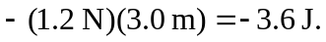 b) The friction force is now to the left, and the work is again 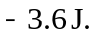 c) 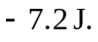 d) The net work done by friction for the round trip is not zero, and friction is not a conservative force.

